Case Study (ISO 9241-210)

Evaluated System: Google Sheets
A Spreadsheet-Based Real Property Assessment Recording and Computation Tool

By:

Asido, Christian Louise O.
Calubad, John Kenneth P.
Ortega, Rizalina A.

October 2026

Table of Contents

Case Study Report 1
A. System Overview 2
B. Identified Users and Context of Use 2
C. Usability Strengths and Issues 3
D. Evaluation Using ISO 9241-210 Framework 4
E. Recommendations for Improvement and Connection to the Proposed System 5
Conformance Checklist 7
F. References and Appendices 19

A. System Overview
Google Sheets is a free, browser-based spreadsheet application that is part of Google Workspace. It runs in any modern desktop browser and also has Android and iOS apps. Files are stored in Google Drive, not on the office computer. One spreadsheet can hold up to 20 million cells. Several people can edit the same file at once, and each person’s cursor appears in a different color. Google first released the product in 2006 after acquiring 2Web Technologies and its XL2Web spreadsheet.
The course instructor asked the proponents to evaluate a system that is close to them and has an interface they can open and use directly. Google Sheets fits that instruction. Its two core features are recording structured data in rows and computing values with formulas, and those are also two of the core functions of the proposed system. Sheets is also the tool many municipal clerks, barangay staff, and students open first when they need to keep a list and total it.
The connection to real property tax (RPT) administration is direct. Assessor and treasurer staff often keep assessment rolls, collection logs, and delinquency lists in spreadsheets, sometimes alongside dedicated tax software. Even Pasacao, which runs a localized eRPT, still moves collection data between offices as batch spreadsheet files. To test Sheets in this setting, the proponents built a mock Pasacao assessment roll with masked owner names, in line with RA 10173. The Assessment_Roll tab records eight tax declarations and computes the Market Value (Area × Unit Value) and the Assessment Level by classification. The levels used are 20% residential, 40% agricultural, and 50% commercial, which are the maximum land rates under Section 218 of RA 7160. The tab then computes the Assessed Value, the 1% Basic RPT, the 1% Special Education Fund levy, and the Total Tax Due. A second tab, Treasurer_Collections, imitates the cashier’s ledger and pulls the tax due from the assessor’s tab through VLOOKUP.
The exercise shows where Sheets helps and where it stops. Once the formula is right, it computes the tax correctly. However, it has no concept of a Transfer of Assessment. It cannot route a document to the Treasurer, and it cannot tell a clerk whether the Provincial Assessor in Pili has signed off. These are the gaps the proposed system is built to close.
1. Core Features Relevant to RPT Recording and Computation
- Grid-Based Record Keeping: Each row holds one tax declaration. Columns hold the TD No., PIN, owner, barangay, classification, area, and unit value. Freeze panes keep the header row visible while the clerk scrolls.
- Formula Computation Engine: Built-in functions such as IF, SUM, VLOOKUP, XLOOKUP (added in August 2022), and ARRAYFORMULA recompute every dependent cell as soon as an input changes.
- Data Validation: Dropdown rules limit a column to listed values, for example Residential, Agricultural, or Commercial. Entries that break the rule are flagged or rejected.
- Sharing, Permissions, and Protected Ranges: Owners grant Viewer, Commenter, or Editor access per person. Protected ranges can lock specific cells or tabs against editing.
- Version History: Edits save automatically. Users can view earlier versions, restore any of them, and name up to 40 versions per file.
- Offline Access: With Chrome or Microsoft Edge and the Google Docs Offline extension, a clerk can keep editing during an internet outage. Changes sync once the connection returns.
2. Interface Views of the System
Figures 1 to 8 show the live Google Sheets interface across the Executive Dashboard, the Municipal Assessment Roll, and the Treasurer Collections ledger. A short note after each figure states the HCI and human-centred design concern that the view raises. All owner names, PINs, and amounts are fictitious.
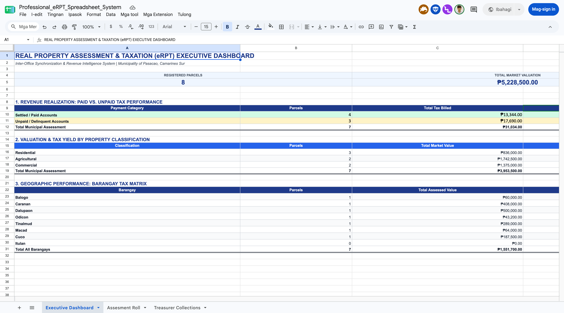
Figure 1. Municipal Real Property Tax (eRPT) Executive Dashboard: KPI summary cards, revenue performance, and property classification matrix (Live Google Sheets, 2026).
The Executive Dashboard establishes a centralized operational overview for municipal administrators. Prominent KPI cards summarize registered parcel counts, aggregate market valuation (₱5,228,500.00), total taxable assessed valuation (₱2,061,700.00), and annual tax due. Beneath the metric cards, dynamic tables track collection performance across property classifications (Residential, Agricultural, Commercial) and across eight constituent barangays. Although this dashboard aggregates real-time data, maintaining it in a cloud spreadsheet requires manual formula maintenance across tabs and lacks automated data pipeline triggers.

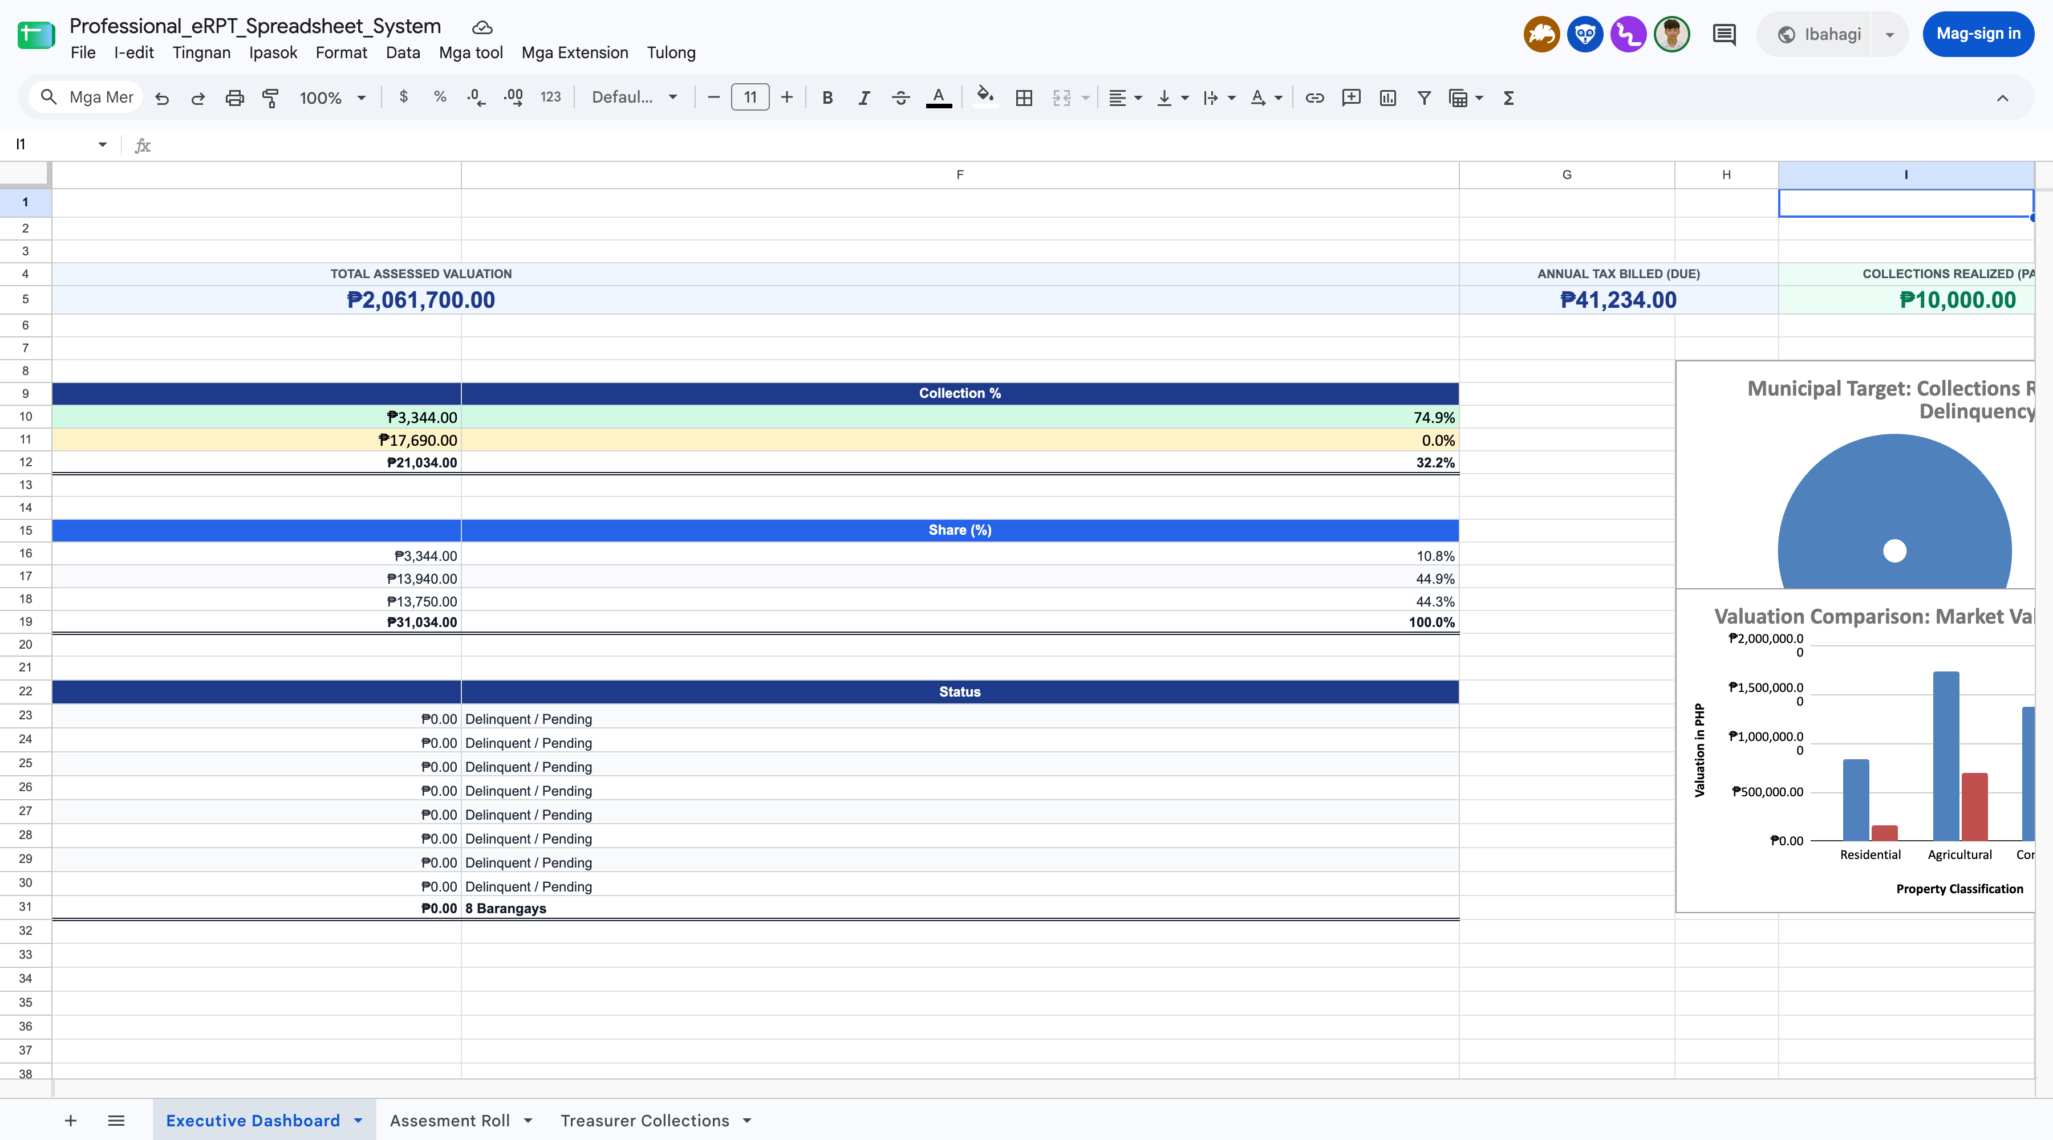
Figure 2. Executive Dashboard revenue analytics: Municipal Target progress (Doughnut Chart) and Valuation Comparison by Classification (Column Chart) (Live Google Sheets, 2026).
Visual analytics enhance executive decision-making by illustrating revenue realization against unpaid municipal delinquency targets. The Doughnut Chart depicts collections realized (Paid accounts) versus outstanding delinquency, providing immediate feedback on collection efficiency. Alongside it, the Clustered Column Chart contrasts total market valuation with assessed taxable valuation across property classes. In an unintegrated spreadsheet environment, however, chart rendering depends on client-side browser performance, and charts cannot trigger automated delinquency notices to property owners.

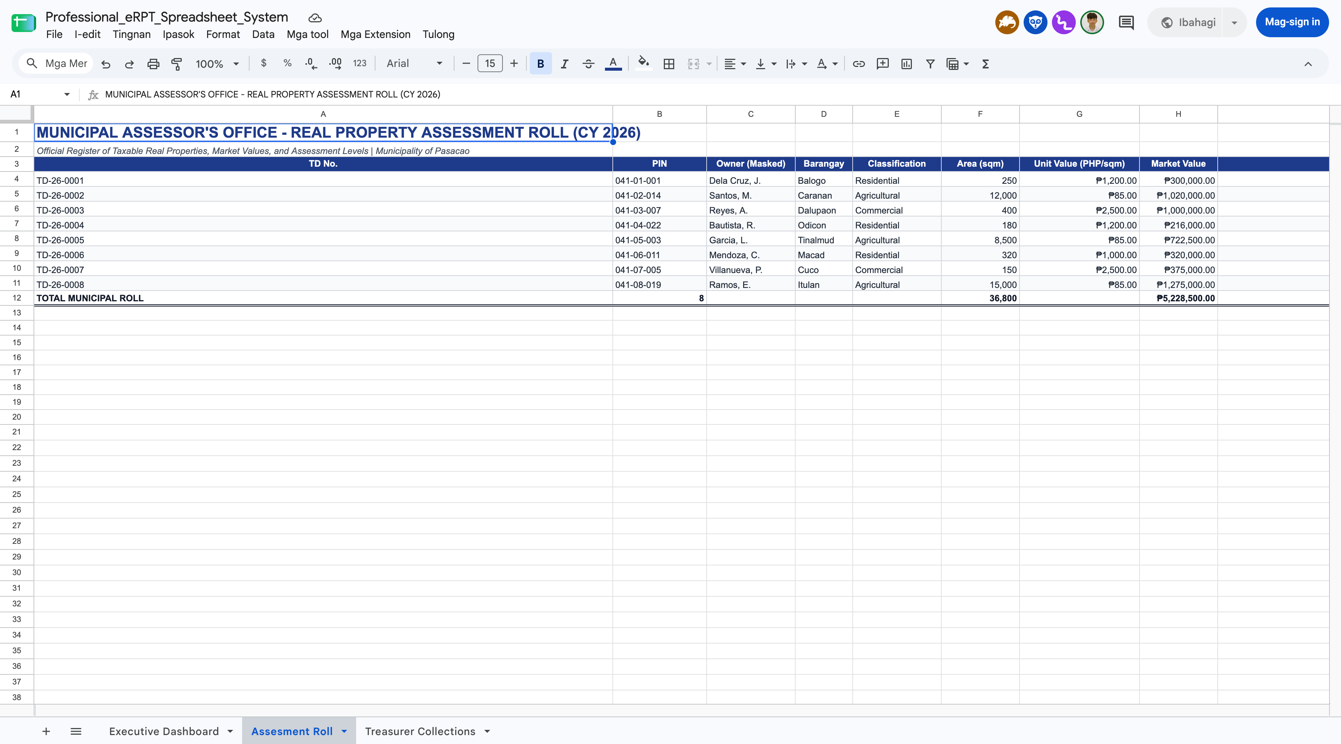
Figure 3. Municipal Assessor’s Office - Real Property Assessment Roll showing 15-column valuation register and payment status tracking (Live Google Sheets, 2026).
The Assessment Roll tab functions as the primary cadastre ledger for the Municipal Assessor’s Office. It records Tax Declaration Numbers (TD No.), Property Identification Numbers (PIN), masked owner names, barangay locations, parcel areas, unit values, market values, statutory assessment levels, and computed taxes (Basic RPT 1% and SEF 1%). Color-coded status chips highlight settled accounts versus unpaid accounts. Because this register contains sensitive ownership information, managing it in Google Sheets exposes citizen records to accidental link-sharing risks under RA 10173.

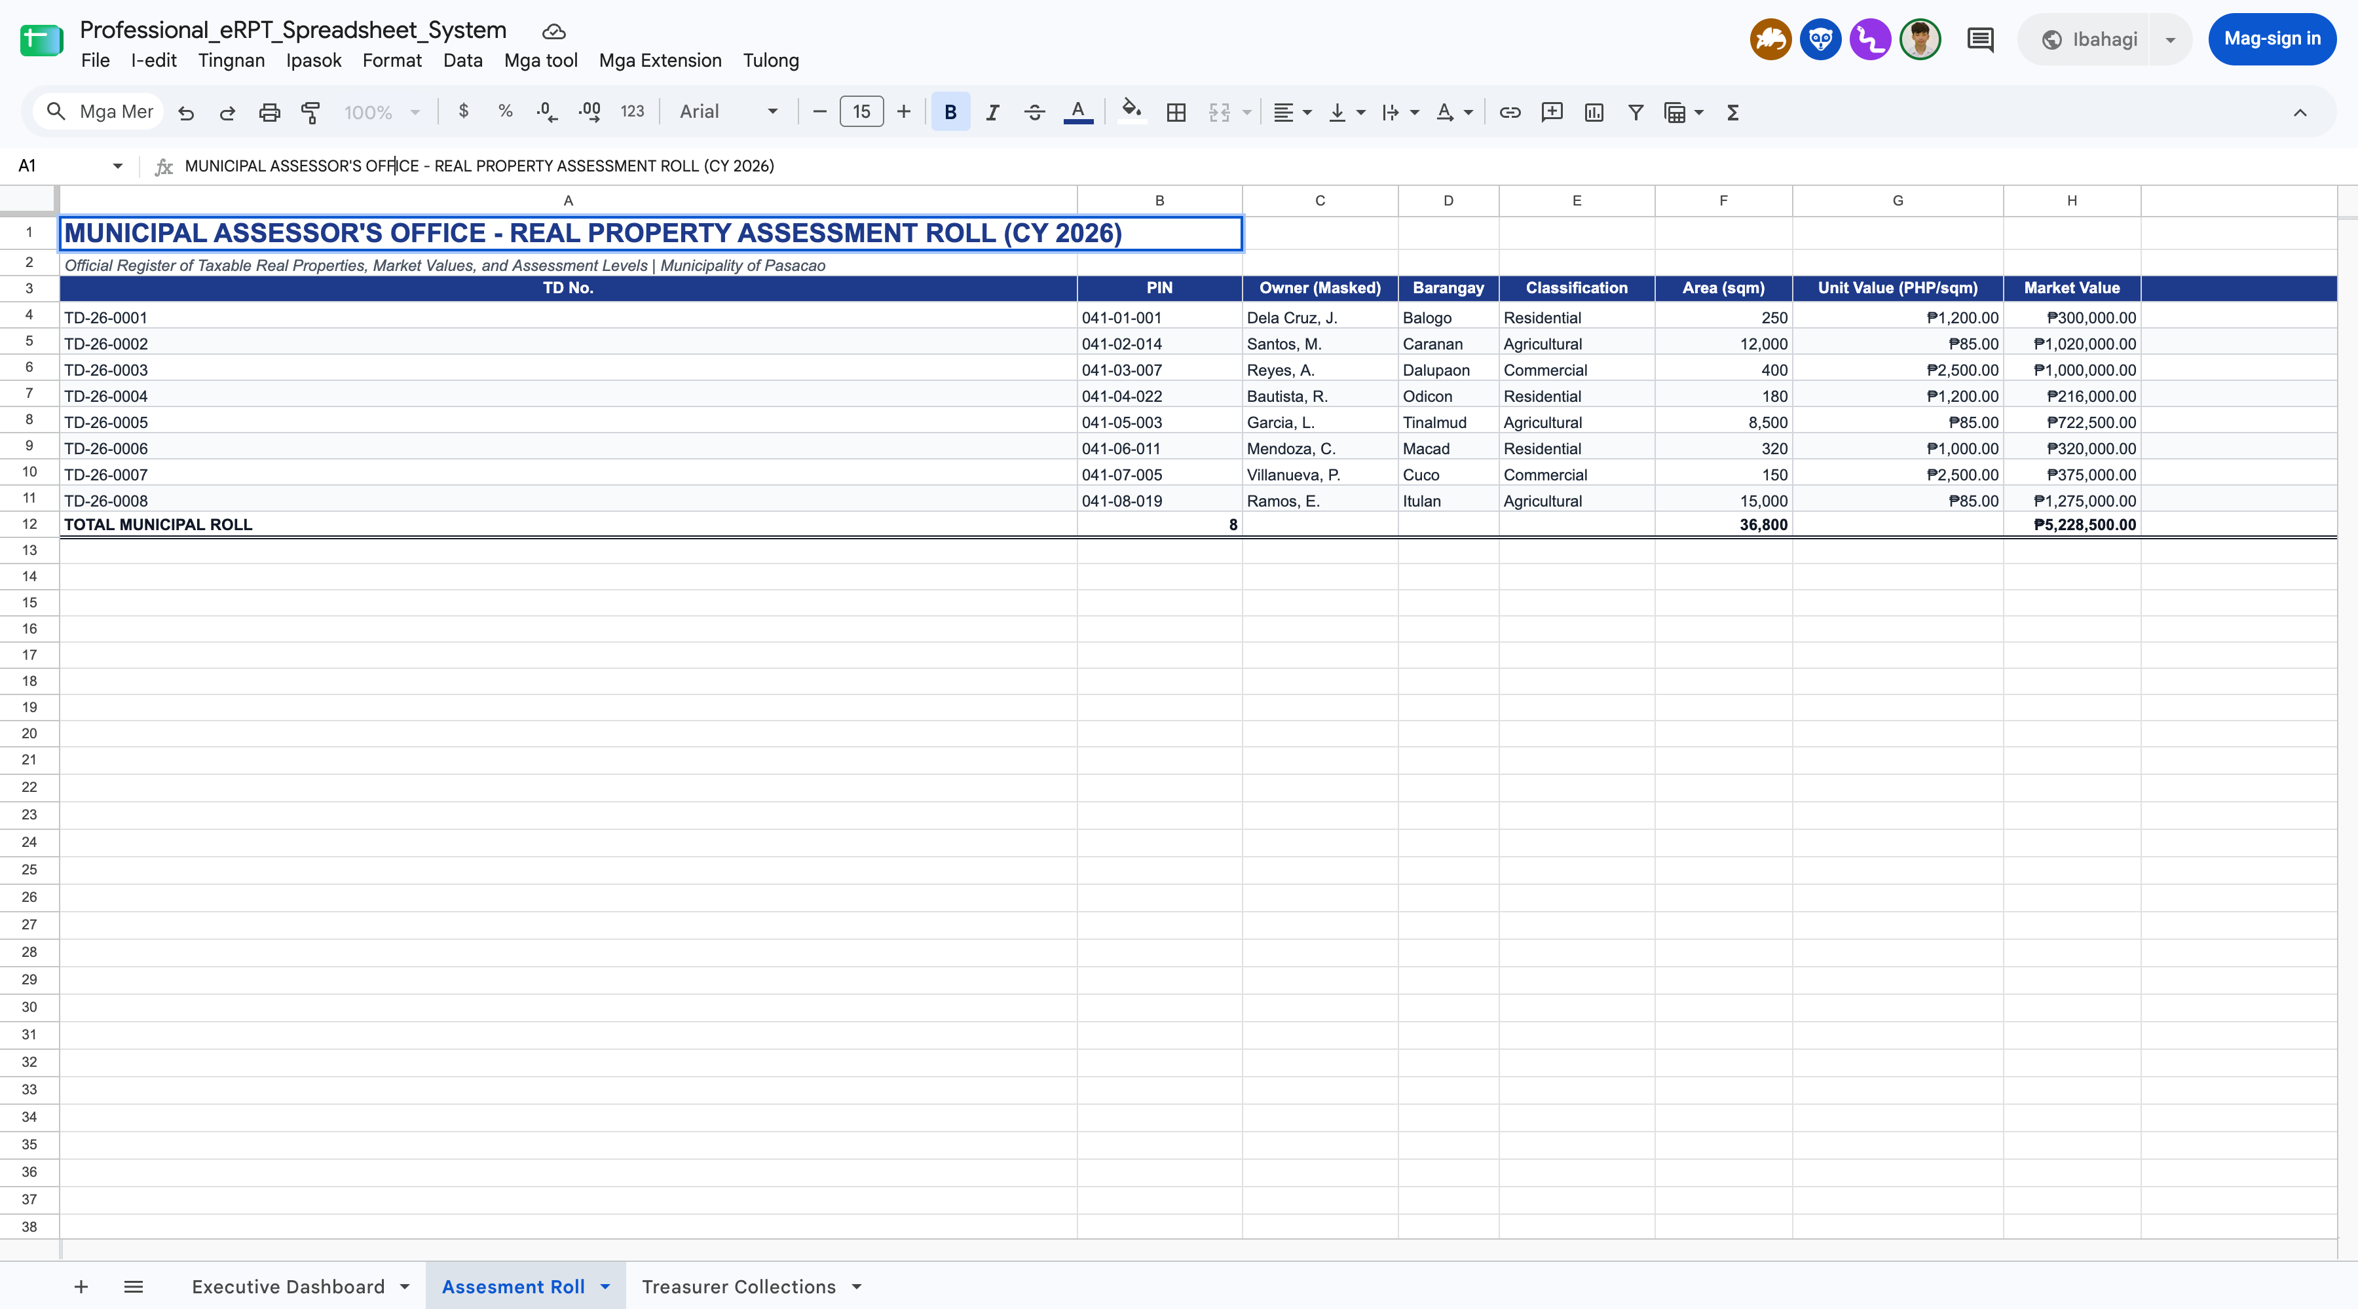
Figure 4. Formula bar exposing automated valuation logic and nested IF classification tiers (Live Google Sheets, 2026).
Clicking on computed cells reveals the underlying computational formulas. The Assessed Value column computes =Market_Value * Assessment_Level, while the Assessment Level column evaluates property classes via nested =IF(E4="Residential", 0.20, IF(E4="Agricultural", 0.40, IF(E4="Commercial", 0.50, 0.20))) logic. Exposing these statutory formulas directly in the spreadsheet grid creates operational vulnerability: an unintentional keystroke or drag-fill by an administrative clerk can overwrite the formula without raising an alert or audit warning.

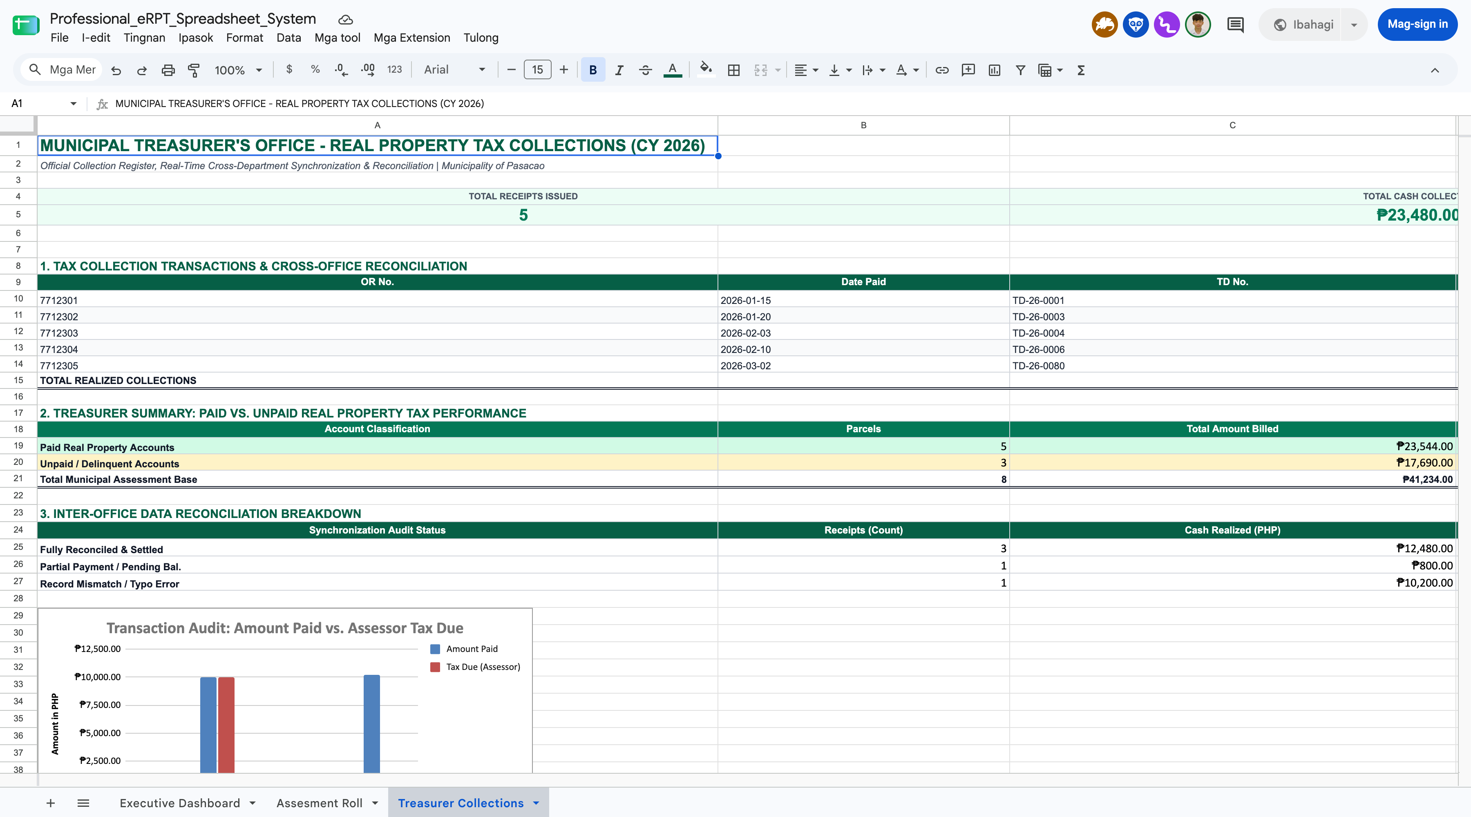
Figure 5. Municipal Treasurer’s Office - Real Property Tax Collections ledger with cross-office VLOOKUP and reconciliation badges (Live Google Sheets, 2026).
The Treasurer Collections tab acts as the cash collection register. Official Receipt numbers, payment dates, and cash receipts are cross-referenced against the Assessor’s Assessment Roll using =IFERROR(VLOOKUP(...), "RECORD NOT FOUND"). A calculated variance column automatically audits whether payments match the assessed tax due. Conditional reconciliation badges classify transactions into 'Fully Settled', 'Partial / Underpaid' (such as the ₱64.00 shortfall on TD-26-0004), and 'Record Missing / Error' (such as the typo on TD-26-0080). This demonstrates that while spreadsheets can compute variances, resolving them still requires manual inter-office cross-checking.

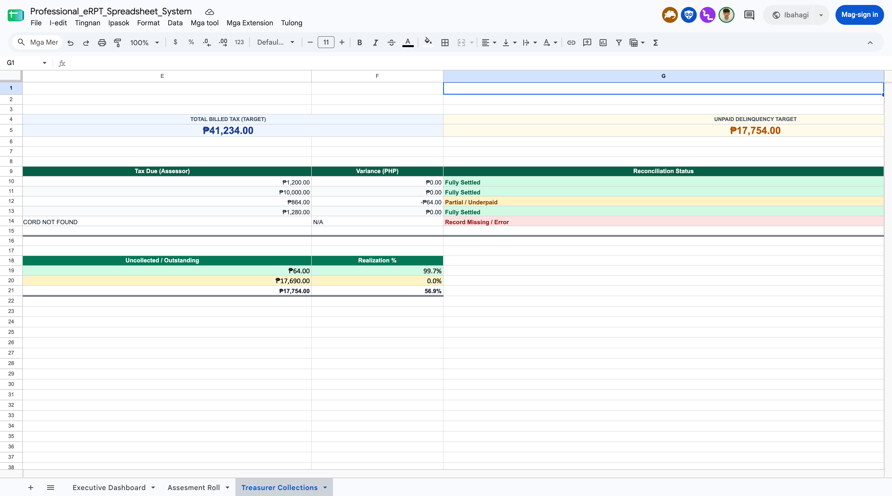
Figure 6. Treasurer Analytics: Paid vs. Unpaid Collections Yield (Doughnut Chart) and Real Property Accounts Distribution (Column Chart) (Live Google Sheets, 2026).
Dedicated visual dashboards on the Treasurer tab monitor municipal cash inflow versus uncollected tax backlog. The 'Treasurer Tax Yield' Doughnut Chart displays the proportion of realized collections against outstanding tax liabilities. Beneath it, the 'Real Property Accounts' Column Chart compares the number of compliant, paid parcels (5 accounts) against delinquent, unpaid parcels (3 accounts). These visualizations allow treasury supervisors to gauge compliance at a glance, though extracting historical compliance trends remains constrained by flat-file data limits.

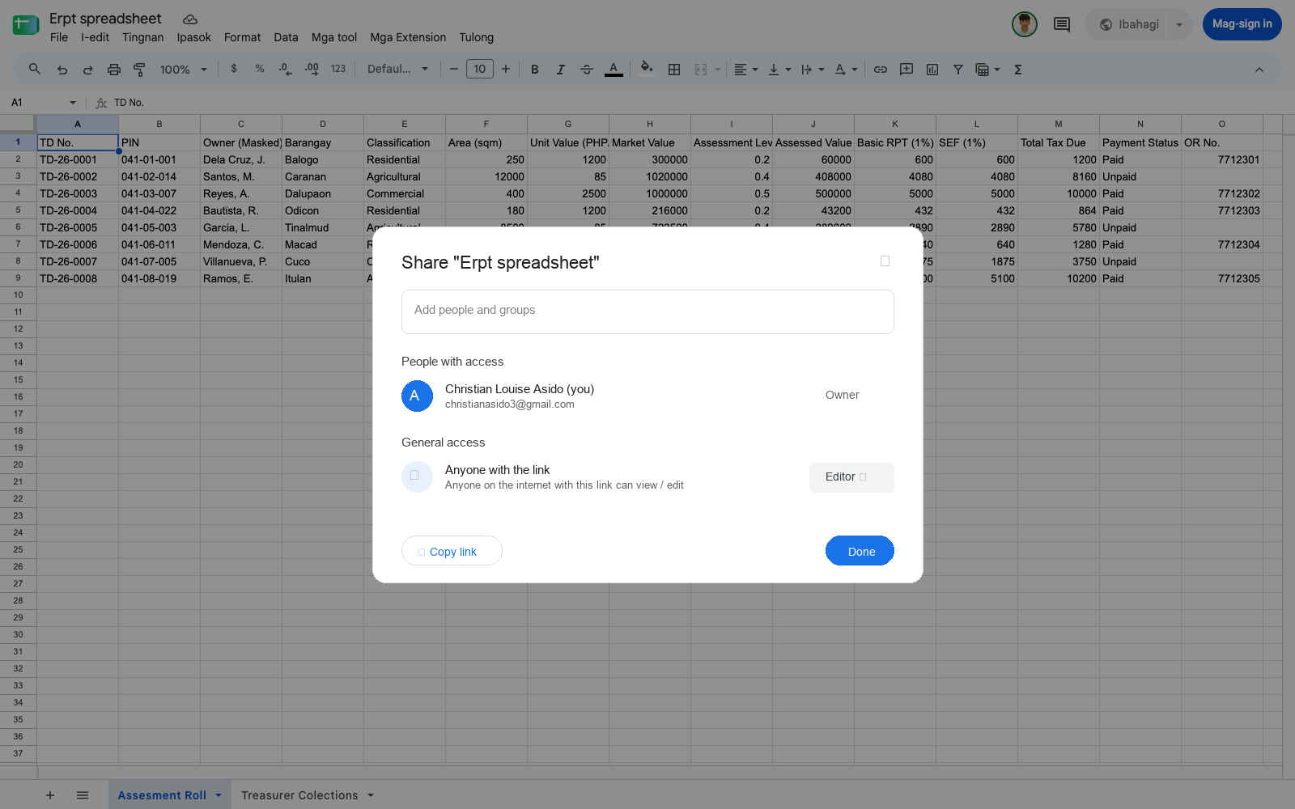
Figure 7. Google Workspace Share modal showing blanket file permissions and General link access (Live Google Sheets, 2026).
Access governance in Google Sheets is administered on an all-or-nothing file basis (Viewer, Commenter, or Editor). Field-level permissions—such as preventing treasury cashiers from editing valuation baselines or preventing assessors from altering payment receipts—cannot be enforced natively. In addition, configuring General access to 'Anyone with the link' allows public, unauthenticated access, violating the data privacy mandates of Republic Act No. 10173.

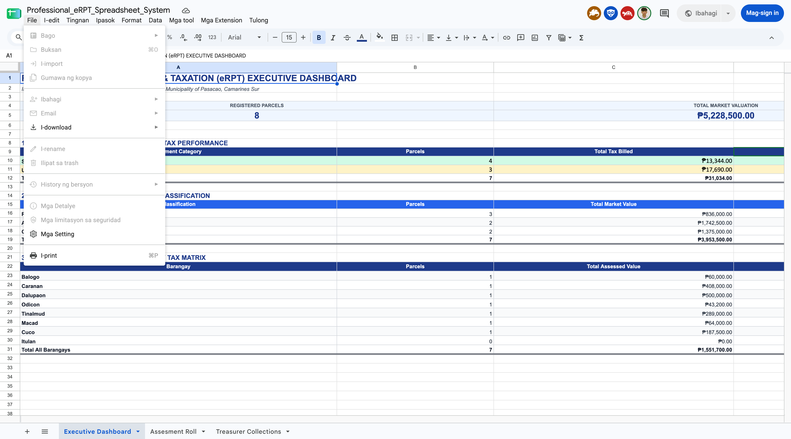
Figure 8. Version history panel listing timestamped revisions without transactional audit metadata (Live Google Sheets, 2026).
The Version History sidebar records chronological revisions and user identities, enabling document rollback. However, it lacks transactional granularity: changes to an individual assessment or tax receipt are aggregated into broad snapshot sessions. The system cannot produce legally binding, immutable audit logs with cryptographic integrity, unlike the dedicated transaction logs required for government fiscal systems.

B. Identified Users and Context of Use
ISO 9241-210 Clause 6.2 requires a clear understanding of who uses a system, for which tasks, with what tools, and in what environment. For Google Sheets used as an RPT ledger, the proponents identified the following groups and conditions from the Pasacao and Canaman field interviews and from hands-on use of the mock roll:
1. Primary User Groups
- Municipal Assessor Personnel (Assessment Clerks, Appraisers, Tax Mappers): These staff encode tax declaration data, apply unit values from the Schedule of Market Values, and maintain the assessment roll. They either write the formulas that compute assessed value or inherit them from whoever built the file.
- Municipal Treasurer Personnel (Revenue Collection Clerks, Cashiers): The cashiers keep a separate collection ledger. They look up the tax due for each TD No., record Official Receipt numbers, and reconcile payments against the assessor’s figures.
- Office Heads (Municipal Assessor, Municipal Treasurer): The heads review totals and delinquency lists, usually with view-only access, and decide who gets edit rights to the file.
2. Secondary User Groups
- Property Owners and Taxpayers: Taxpayers never touch the sheet, but their bills come from it. A broken formula turns into an overcharge or undercharge at the counter.
- Provincial Assessor’s Office (Pili): This office receives printed or emailed extracts for review and approval. It cannot see the current state of the municipal file.
- Local MIS or IT Staff: Where an IT officer exists, that person manages Google accounts and sharing. Where none exists, files can end up shared from clerks’ personal Gmail accounts.
3. Context of Use, Hardware, and Environmental Conditions
Staff work inside municipal halls from 8:00 AM to 5:00 PM, Monday to Friday. The heaviest load comes in January, when early payers claim the prompt-payment discount, and again near the quarterly deadlines.
The setting places these constraints on spreadsheet use:
- Hardware and Terminals: Staff use shared Windows desktops or laptops with a browser. Sheets needs no installation, only a supported browser and a Google account. Some offices still print forms on dot-matrix printers.
- Network Infrastructure: Sheets is built for the cloud. Rural connections in Camarines Sur drop out often, and offline mode works only if someone switched it on beforehand in that browser.
- Physical Office Environment: Counters are noisy, queues are long, and rooms get hot. A brownout stops work on desktops without a UPS. After a dropped connection, the clerk cannot be sure the last entries were saved.
- Legacy Paper Ledgers: Records going back to 1949 still have to be read from paper and typed in row by row. Sheets offers no structured way to bring them in.
- Data Privacy Conditions: Owner names, addresses, and property values are personal information under RA 10173. On a free consumer account, the LGU has little administrative control over where a file goes once it is shared or downloaded.

C. Usability Strengths and Issues
Hands-on use of the mock roll showed clear strengths, along with usability problems that become serious once the data is public revenue:
1. Usability Strengths
- Low Learning Barrier: The grid, A1 cell references, and formula syntax follow Excel conventions. Function autocomplete shows each function’s arguments as the clerk types.
- Instant Computation: When the clerk changes the area or unit value, the market value, assessed value, and total tax due update on the spot. Nobody has to redo the arithmetic by hand (Figures 2 and 3).
- Real-Time Collaboration: Two clerks can encode different rows at the same time. Comments and @mentions let them ask questions inside the file instead of leaving their desks.
- Error Recovery: Undo and version history can roll back a bad edit, and data validation blocks invalid classifications before they reach the formulas (Figures 4 and 7).
- Zero Installation and Low Cost: Sheets runs in any modern browser and is free with a Google account. For an LGU with no IT budget, that matters.
2. Usability Issues and Operational Pain Points
- Fragile, Hidden Formulas: The tax logic is written in cell references. Deleting a column or pasting over a formula breaks the computation chain without any warning, and the wrong tax due still looks like a normal number.
- Manual Inter-Office Matching: The Assessor and the Treasurer keep separate tabs or files. Matching between them depends on typing the TD No. exactly (Figure 5). VLOOKUP or IMPORTRANGE can link the files, but someone has to build and maintain that link, and one typo breaks it.
- No Workflow or Status Tracking: A “Status” column is plain text. Sheets cannot route a Transfer of Assessment, enforce the order of approvals, or show where a document is between the municipality and Pili. In Pasacao, transfers still take more than seven days. In Canaman, building assessments wait 7 to 14 days for provincial approval.
- Cryptic Error Feedback: Codes such as #VALUE!, #REF!, and #N/A mean little to a clerk unless they hover over the cell or already know what the code means.
- Weak Governance for Public Records: Anyone with edit access can change a rate, and “Anyone with the link” sharing can expose taxpayer data. Appraisal entry and cashiering stay separate only if protected ranges are set up carefully, and in small offices that rarely happens.
- Internet Dependence: Offline editing needs prior setup on Chrome or Edge. Without it, a service interruption stops the counter.

D. Evaluation Using ISO 9241-210 Framework
ISO 9241-210:2010 sets requirements and recommendations for human-centred design across the life cycle of an interactive system. Annex B, Table B.1, gives the checklist for assessing conformance. The proponents evaluated Google Sheets against that checklist using three sources: Google’s public documentation (Help Center articles, the Workspace Updates blog, and the Google Accessibility Conformance Reports), a hands-on walkthrough of the mock assessment roll (Figures 1 to 7), and the Pasacao and Canaman findings from the proponents’ needs assessment.
Synthesis of Human-Centered Design Conformance
The results fall along one dividing line. As a general spreadsheet product, Google Sheets shows strong human-centred design: 64 of the 103 checklist items were met. As an RPT ledger, it falls short on the remaining 39, mostly because Google never designed it for municipal tax work. In that setting, the LGU staff become the designers, and they have no HCD process at all.
Under Clause 4 (Principles), Sheets meets Principle 4.5 (iteration) through a steady stream of releases, from XLOOKUP in 2022 to the Tables feature in 2024. It meets Principle 4.6 by keeping Excel’s mental model, so trained clerks need almost no retraining. It fails Principle 4.2 for this context, because assessors, cashiers, and taxpayers are not identified user groups. It also fails the function-allocation items of 4.6. Error-prone work, such as matching records between offices and checking formulas, stays with the clerk instead of moving to the system.
Clause 5 (Planning) is the hardest to verify. Google does not publish its internal HCD plans, milestones, or trade-off rationales, so those items are marked “No” under the evidence rule. Some planning is visible, though. Staged Rapid and Scheduled Release tracks, early-access programs, and Material Design guidelines all point to a planned feedback cycle. What is missing for the LGU case is any assessment of risk. A wrong cell reference in a public revenue file quietly changes what a taxpayer owes.
Clauses 6.2 and 6.3 (Context and Requirements) split the same way. Google documents the technical context in detail: supported browsers, offline setup, and the 20-million-cell limit. The municipal context is not covered at all. Brownouts, shared terminals, January queues, 1949 paper ledgers, and the Assessor-Treasurer-Province approval chain are outside the product’s scope. There are no measurable usability criteria such as task time or error rate, so the requirements cannot be tested in the sense that Clause 6.3.5 expects.
Under Clauses 6.4 and 6.5 (Design and Evaluation), Sheets does well on most ISO 9241-110 dialogue principles: suitability for the task, conformity with expectations, controllability, error tolerance, and individualization. It is weaker on self-descriptiveness, because formulas and error codes need prior knowledge to read (Figures 2, 3, and 5). It also has no concept of task sequence. A record can be marked “Paid” before it is assessed. On evaluation, Google’s Accessibility Conformance Reports apply WCAG 2.1 methods with experienced testers. No evaluation covers high-risk uses such as computing local taxes, and nobody tested Sheets with municipal clerks doing RPT tasks.

E. Recommendations for Improvement and Connection to the Proposed System
The checklist findings point to five design recommendations for spreadsheet-based RPT record keeping. Each one carries into a specific part of the proposed system:
- 1. Replace Hand-Built Formulas with Locked, Rule-Based Computation: In Sheets, assessment levels and tax rates live inside editable formulas (Figure 4). Recommendation: keep the rates in a single reference table and lock every computed column. Lesson Applied to the Proposed System: the proposed system computes assessed value and tax due in its application tier, using one rate table that only authorized administrators can change. A rate revision then takes effect everywhere at once.
- 2. Link Assessor and Treasurer Records by Key, Not by Typed Text: The cashier’s VLOOKUP fails on a single wrong digit (Figure 5). Recommendation: select records from a controlled list and share one record between the two offices instead of keeping two copies. Lesson Applied to the Proposed System: the Tax Payment Synchronization Module lets the Treasurer’s validation view read the same database record the Assessor maintains. Nobody retypes data, and nobody cross-checks by hand.
- 3. Add Workflow States and Document Tracking: In Sheets, status is a free-text column with no rules and no timestamps. Recommendation: define each stage of a request, the allowed moves between stages, and the time each move happens. Lesson Applied to the Proposed System: the Assessment Request Routing and Document Tracking Module, together with the Administrative Workflow Panel, shows where each request is between the Assessor, the Treasurer, and the Provincial Capitol in Pili. It logs the time at every step, so the 7-to-14-day waits become measurable.
- 4. Make Errors Self-Explanatory and Labels Task-Based: Codes such as #VALUE! and formulas written in cell addresses work against self-descriptiveness. Recommendation: write validation messages in tax terms and label every field by its meaning. Lesson Applied to the Proposed System: the proposed system uses labelled fields (Market Value, Assessment Level, Assessed Value) with inline messages such as “TD No. not found in the assessment roll. Check the number or contact the Assessor’s Office.”
- 5. Enforce Role-Based Access and Test with Real Clerks: Sheets controls access per file, and link sharing is easy to switch on (Figure 7). Recommendation: set permissions per function, keep an audit log, and run usability tests with the people who will use the system. Lesson Applied to the Proposed System: role-based access control separates Assessor entry from Treasurer validation. Live records are encrypted under RA 10173, and development uses only mock data. Two-week Agile sprints end with ISO/IEC 25010 evaluations by staff from Pasacao, Canaman, Magarao, and San Fernando.

Conformance Checklist
Completed ISO 9241-210:2010 Conformance Checklist (Table B.1): Google Sheets

This checklist evaluates Google Sheets, as used for RPT assessment recording and computation, against ISO 9241-210:2010 Annex B Table B.1. Items are judged on two grounds: what Google publicly documents about the product, and how well the product serves the municipal Assessor and Treasurer context described in Section B. Items with no verifiable public evidence are marked ‘No,’ and the comments column explains each judgment.
Summary: 64 of 103 items met; 39 not met; all 103 items judged applicable.

Clause | Requirement / Recommendation | Applicable (Y/N) | Reason N/A | Met Y | Met N | Evaluation Comments & Evidence
4.1 | Human-centred approach follows principles in 4.1 | Y |  | Y |  | Google applies Material Design guidelines and UX research across Workspace. The approach is user-centred for general spreadsheet work, not for LGU tax administration.
4.2 | Design takes account of people using system and affected stakeholders | Y |  | Y |  | Sheets serves individual, education, and business users, including people who only view or comment on a file.
4.2 | All relevant user and stakeholder groups identified [see 6.2.2 a)] | Y |  |  | N | Municipal assessors, cashiers, and taxpayers are not identified groups. RPT offices must adapt a general tool themselves.
4.3 | User involvement is active | Y |  | Y |  | User input is gathered through Help > Help Sheets improve and through early-access programs before general release.
4.3 | Users involved reflect capabilities, characteristics, and experience [6.2.2 b)] | Y |  |  | N | Feedback comes from Google’s broad user base. Rural clerks with limited spreadsheet literacy are not specifically represented.
4.4 | User-centred evaluation takes place as part of final product acceptance | Y |  | Y |  | Features roll out in stages through Rapid and Scheduled Release tracks, so user response is observed before full release.
4.5 | Iteration used to progressively eliminate uncertainty during development | Y |  | Y |  | The Workspace Updates blog records frequent Sheets releases, e.g., XLOOKUP (Aug. 2022) and Tables (May 2024).
4.6 | User experience of previous systems and branding considered | Y |  | Y |  | Grid layout, A1 references, and formula syntax mirror Excel, so trained clerks carry over their skills (Figure 1).
4.6 | Users' strengths, limitations, preferences, and expectations considered in function allocation | Y |  |  | N | Formula writing, record checking, and cross-office matching stay with the clerk. Error-prone RPT tasks are not shifted to the system.
4.6 | Representative users involved in decisions on allocation of function | Y |  |  | N | No evidence that LGU staff helped decide which RPT tasks Sheets automates. Clerks build their own formulas.
4.6 | Human activities resulting from function allocation form a meaningful set of tasks | Y |  | Y |  | Encoding, computing, sorting, and filtering form a coherent task set that matches daily ledger work.
4.7 | Human-centred design team includes multidisciplinary skills and perspectives | Y |  | Y |  | Google staffs Workspace with UX researchers, interaction designers, accessibility specialists, and engineers.
5.1 | Human-centred design planned and integrated into all life cycle phases | Y |  | Y |  | Public Material Design 3 guidance and staged releases show HCD built into Google’s product life cycle.
5.2 a) | Evaluate how usability relates to purpose and use of product | Y |  | Y |  | Usability is central to Sheets’ purpose as a self-service tool that people use without formal training.
5.2 b) | Evaluate levels of risk resulting from poor usability | Y |  |  | N | The risk of formula errors in public revenue records is not addressed. A wrong reference silently changes a taxpayer’s assessed value.
5.2 c) | Evaluate nature of development environment | Y |  | Y |  | As a cloud web app, Sheets ships updates to all users without local installation.
5.3 a) | Identify appropriate HCD methods and resources for Clause 6 activities | Y |  |  | N | The specific HCD methods and resources used for Sheets are not published, so this item cannot be verified.
5.3 b) | Define procedures for integrating HCD activities with system development | Y |  |  | N | Internal procedures linking HCD activities to engineering work are not publicly documented.
5.3 c) | Identify individuals/organizations responsible for HCD activities and skills | Y |  | Y |  | Accessibility and Workspace UX roles are publicly identified functions within Google.
5.3 d) | Develop feedback and communication procedures on HCD and trade-offs | Y |  |  | N | Changes are announced, but the human-factors reasons behind trade-offs are rarely documented.
5.3 e) | Agree on appropriate milestones for HCD integrated into schedule | Y |  |  | N | HCD milestones in Google’s development schedule are not public.
5.3 f) | Agree on suitable timescales for iteration and incorporating user feedback | Y |  | Y |  | Release tracks set a fixed window for collecting feedback before a feature reaches all users.
5.4 | HCD plan forms part of overall system development project plan | Y |  |  | N | Not verifiable from public sources.
5.4 | HCD plan subject to same project disciplines as other key activities | Y |  |  | N | Not verifiable from public sources.
5.4 | HCD aspects of project plan reviewed and revised as requirements change | Y |  | Y |  | Workspace Updates posts often cite user feedback as the reason for a change, showing that plans are revised.
5.5 | Project planning allocates time and resources to HCD activities | Y |  |  | N | Resource allocation for HCD is internal to Google and not published.
5.5 | Plan includes time for iteration and user feedback on user requirements | Y |  | Y |  | Staged rollouts and early-access programs leave time for user feedback before general availability.
5.5 | Additional time allocated to communication among design team on trade-offs | Y |  |  | N | Time set aside for design-team communication on trade-offs is not documented.
5.5 | HCD activities start at earliest stage of the project | Y |  |  | N | Sheets began as an acquired product (XL2Web, 2006). Early-stage HCD activity is undocumented.
5.5 | HCD aspects of project plan reviewed throughout life of project | Y |  | Y |  | Two decades of interface updates, including the Material Design 3 refresh, show review throughout the product’s life.
6.1 a) | Understand and specify context of use | Y |  | Y |  | Desktop, mobile, and offline contexts are specified in Google’s documentation.
6.1 b) | Specify user requirements | Y |  | Y |  | Supported tasks and limits (e.g., 20 million cells per file) are specified in the Help Center.
6.1 c) | Produce design solutions | Y |  | Y |  | Design solutions such as the formula bar, Smart Fill, and dropdown chips are produced and refined across releases.
6.1 d) | Evaluate design against requirements | Y |  | Y |  | Accessibility Conformance Reports evaluate Sheets against WCAG 2.1 and Section 508.
6.2.2 a) | Relevant groups identified with key goals and constraints | Y |  | Y |  | Owner, Editor, Commenter, and Viewer are defined roles with distinct goals in the sharing model (Figure 7).
6.2.2 b) | Relevant characteristics of users identified | Y |  |  | N | Characteristics of LGU clerks, such as spreadsheet literacy and typing load, are not considered by a general product.
6.2.2 b) | Characteristics of different types of users defined if necessary | Y |  | Y |  | Personal, education, and business users are separated through Workspace editions and admin controls.
6.2.2 b) | Designed for widest range of capabilities to achieve accessibility | Y |  | Y |  | Screen reader, braille, and magnifier support is documented, and ACRs report WCAG 2.1 conformance.
6.2.2 c) | User goals and overall system goals identified | Y |  | Y |  | The goal of organizing, computing, and sharing tabular data is clearly stated.
6.2.2 c) | Task characteristics influencing usability and accessibility described | Y |  |  | N | RPT tasks (appraisal, transfer, endorsement) follow legal sequences that Sheets neither describes nor supports.
6.2.2 c) | Potential adverse consequences for health and safety identified | Y |  |  | N | No guidance covers eye strain from long encoding sessions on dense grids during peak tax season.
6.2.2 c) | Risk of task completed incorrectly identified | Y |  |  | N | A wrong assessment level or a broken formula chain is not flagged. The error flows straight into the tax due.
6.2.2 c) | Tasks not described solely in terms of system functions or features | Y |  |  | N | Documentation describes features and functions, not municipal tasks such as a Transfer of Assessment.
6.2.2 d) | Technical environment (hardware, software, materials) identified | Y |  | Y |  | Supported browsers and offline requirements (Chrome or Edge plus the Docs Offline extension) are documented.
6.2.2 d) | Physical, social, organizational, and cultural environment described | Y |  |  | N | Crowded counters, brownouts, and shared PCs in municipal halls are outside the described context.
6.2.3 | Context of use described in sufficient detail to support HCD activities | Y |  |  | N | For RPT work, the context lacks the approval chain between Assessor, Treasurer, and Provincial Capitol.
6.2.4 | Intended context of use specified as part of user requirements | Y |  | Y |  | General office and personal data work is the stated intended context.
6.3.1 | Explicit statement of user requirements in relation to context and objectives | Y |  | Y |  | Collaboration, computation, and sharing requirements are stated in the product’s documentation.
6.3.1 | Involve organizational stakeholders to optimize organizational and technical systems | Y |  |  | N | The split between the Assessor and Treasurer offices is not reflected. Each office keeps its own file.
6.3.2 | User and stakeholder needs identified, taking account of context of use | Y |  | Y |  | Needs for collaboration and access from anywhere are met by cloud storage and real-time co-editing.
6.3.2 | User needs include what to achieve and constraints imposed by context | Y |  |  | N | Unstable rural internet is only partly addressed. Offline mode has to be set up in advance on each browser.
6.3.3 a) | Specification of user requirements includes intended context of use | Y |  | Y |  | Offline, mobile, and desktop contexts appear in the documented conditions of use.
6.3.3 b) | Requirements derived from user needs and context of use | Y |  | Y |  | Features such as Smart Fill and assignable comments respond to observed user needs.
6.3.3 c) | Requirements arising from ergonomics and UI knowledge, standards, guidelines | Y |  | Y |  | Material Design and WCAG 2.1 guidelines inform the interface.
6.3.3 d) | Usability requirements include measurable performance and satisfaction criteria | Y |  |  | N | No published task-time, error-rate, or satisfaction targets exist for Sheets.
6.3.3 e) | Requirements derived from organizational requirements directly affecting user | Y |  |  | N | LGU requirements such as per-transaction audit trails and RA 10173 controls must be added by the user.
6.3.4 | Potential conflicts between user requirements resolved | Y |  | Y |  | Simplicity and power are balanced by keeping advanced tools in menus and offering Apps Script for advanced users.
6.3.4 | Rationales, factors, and weighting of human-system issues in trade-offs documented | Y |  |  | N | Rationales for human-system trade-offs are not published.
6.3.5 a) | User requirements stated in terms that permit subsequent testing | Y |  |  | N | No testable usability requirements are publicly stated.
6.3.5 b) | User requirements verified by relevant stakeholders | Y |  |  | N | Not verifiable. LGU stakeholders were never involved in verifying requirements.
6.3.5 c) | User requirements internally consistent | Y |  | Y |  | Docs, Sheets, and Slides behave consistently, with shared menus, the same sharing model, and the same version history.
6.3.5 d) | User requirements updated as necessary during life of project | Y |  | Y |  | Requirements change with releases. New functions and the Tables feature were added in response to user demand.
6.4.1 a) | Design user tasks, interaction, and user interface considering overall UX | Y |  | Y |  | The toolbar, formula bar, and context menus are designed as one consistent workspace (Figure 1).
6.4.1 b) | Make design solutions more concrete (e.g. prototypes, mockups) | Y |  | Y |  | Features reach users first through early-access and Rapid Release tracks, which act as working prototypes.
6.4.1 c) | Alter design solutions in response to user-centred evaluation and feedback | Y |  | Y |  | Feedback sent through Help > Help Sheets improve feeds into feature revisions.
6.4.1 d) | Communicate design solutions to those responsible for implementation | Y |  | Y |  | Material Design specifications give designers and engineers a shared design language.
6.4.2.1 a) | Dialogue principle: Suitability for the task | Y |  | Y |  | Formulas compute market value, assessed value, and tax due instantly, which fits the clerk’s computation task (Figures 3–4).
6.4.2.1 b) | Dialogue principle: Self-descriptiveness | Y |  |  | N | Error codes such as #VALUE! need a hover to explain them, and hard-coded rates mean nothing to a new clerk (Figures 4 and 5).
6.4.2.1 c) | Dialogue principle: Conformity with user expectations | Y |  | Y |  | Behavior and shortcuts match Excel, so the product does what users expect.
6.4.2.1 d) | Dialogue principle: Suitability for learning | Y |  | Y |  | Function autocomplete with argument hints and the shortcut list (Ctrl+/) support learning.
6.4.2.1 e) | Dialogue principle: Controllability | Y |  | Y |  | Users control pace and navigation, and filter views let one clerk sort without disturbing others.
6.4.2.1 f) | Dialogue principle: Error tolerance | Y |  | Y |  | Undo, version restore, and data validation allow recovery from mistakes (Figures 7 and 8).
6.4.2.1 g) | Dialogue principle: Suitability for individualization | Y |  | Y |  | Zoom, custom number formats, themes, and freeze panes let users adjust the workspace.
6.4.2.2 a) | Interaction design: Making high-level decisions | Y |  | Y |  | Choosing a browser-based, cloud-synced grid is a clear high-level design decision.
6.4.2.2 b) | Interaction design: Identifying tasks and sub-tasks | Y |  |  | N | RPT sub-tasks (appraisal, approval, endorsement, payment posting) are not modelled. Clerks improvise structure with columns.
6.4.2.2 c) | Interaction design: Allocating tasks to user and system | Y |  |  | N | Recalculation is automated, but matching records between offices stays manual (Figure 5).
6.4.2.2 d) | Interaction design: Identifying required interaction objects | Y |  | Y |  | Cells, dropdown chips, checkboxes, and smart chips are well-defined interaction objects.
6.4.2.2 e) | Interaction design: Identifying appropriate dialogue techniques | Y |  | Y |  | Direct manipulation, menus, and typed formula entry are combined appropriately.
6.4.2.2 f) | Interaction design: Designing sequence and timing (dynamics) | Y |  |  | N | Nothing enforces the order of steps. A record can be marked “Paid” before it is assessed, and there are no deadlines.
6.4.2.2 g) | Interaction design: Designing information architecture of UI | Y |  | Y |  | Menus (File, Edit, View, Insert, Format, Data, Tools) group functions logically, and tabs separate datasets.
6.4.2.3 | Ergonomics and UI standards used to inform hardware and software design | Y |  | Y |  | The software design follows WCAG 2.1 and Material Design. No hardware is involved.
6.4.3 | Level of detail and realism of prototypes appropriate to issues investigated | Y |  | Y |  | Live features in early-access releases are realistic prototypes.
6.4.4 | Feedback from evaluation used to improve and refine system | Y |  | Y |  | Workspace Updates posts note changes made in response to user feedback.
6.4.4 | Costs and benefits of proposed changes evaluated to inform modifications | Y |  |  | N | Cost-benefit analyses of design changes are not publicly documented.
6.4.4 | Project plans allow sufficient time for making changes from feedback | Y |  | Y |  | Continuous cloud deployment allows changes at any time without users reinstalling anything.
6.4.5 | Sustained channel of communication between HCD and project team | Y |  | Y |  | The feedback tool, the Docs Editors Community forum, and the Workspace Updates blog form ongoing channels.
6.4.5 | Design solutions accompanied by explanation and justification of decisions | Y |  | Y |  | Workspace Updates posts explain what changed, who is affected, and why.
6.4.5 | Design communication takes account of project constraints and team knowledge | Y |  | Y |  | Updates state edition availability and rollout pace, which takes admin constraints into account.
6.5.1 | User-centred evaluation is a required activity in human-centred design | Y |  | Y |  | ACR testing and staged rollouts show that evaluation is an ongoing activity.
6.5.1 | Design concepts evaluated early to obtain better understanding of user needs | Y |  |  | N | Early concept evaluation for Sheets is undocumented.
6.5.1 | Design solutions evaluated in other ways if user testing impractical | Y |  | Y |  | ACRs combine automated checks with expert review using assistive technologies.
6.5.2 a) | Allocate resources for early feedback and validating requirement satisfaction | Y |  | Y |  | Early-access programs set aside a user base for early feedback.
6.5.2 b) | Plan user-centred evaluation so that it fits project schedule | Y |  | Y |  | Release tracks fit evaluation into the rollout calendar.
6.5.2 c) | Carry out sufficiently comprehensive testing to give meaningful results | Y |  |  | N | No published testing covers government revenue or LGU record-keeping scenarios.
6.5.2 d) | Analyse results, prioritize issues, and propose solutions | Y |  |  | N | How issues are prioritized is internal and not published.
6.5.2 e) | Communicate solutions appropriately to design team | Y |  | Y |  | Fixes and changes are communicated through the Workspace Updates blog and release notes.
6.5.3 | Evaluation carried out by experienced evaluators | Y |  | Y |  | ACRs are prepared by Google’s accessibility specialists using WCAG methods.
6.5.3 | Evaluation uses appropriate methods | Y |  | Y |  | Manual screen-reader testing plus automated checks are appropriate methods for accessibility evaluation.
6.5.3 | Resources allocated for early feedback and summative requirement validation | Y |  |  | N | Results of summative usability validation are not published.
6.5.3 | Extent of summative evaluation depends on risks of not meeting requirements | Y |  |  | N | High-risk uses such as computing local taxes are not treated as a separate evaluation case.
6.5.4 | Users carry out tasks using prototype rather than just shown demonstrations | Y |  | Y |  | Early-access users do real work with pre-release features instead of watching demonstrations.
6.5.6 | HCD process includes long-term monitoring of product use | Y |  | Y |  | As a cloud service, Sheets allows Google to monitor feature use and collect feedback over time.
6.5.6 | Long-term monitoring criteria sensitive enough to identify problems early | Y |  |  | N | Monitoring is aggregate, so problems specific to small LGU users (e.g., broken VLOOKUP chains) would not surface early.

F. References and Appendices

This section presents the workflow and life-cycle diagrams that summarize the evaluation, followed by the formal references.
Appendix 1: System Workflow Visuals and Architectural Diagrams
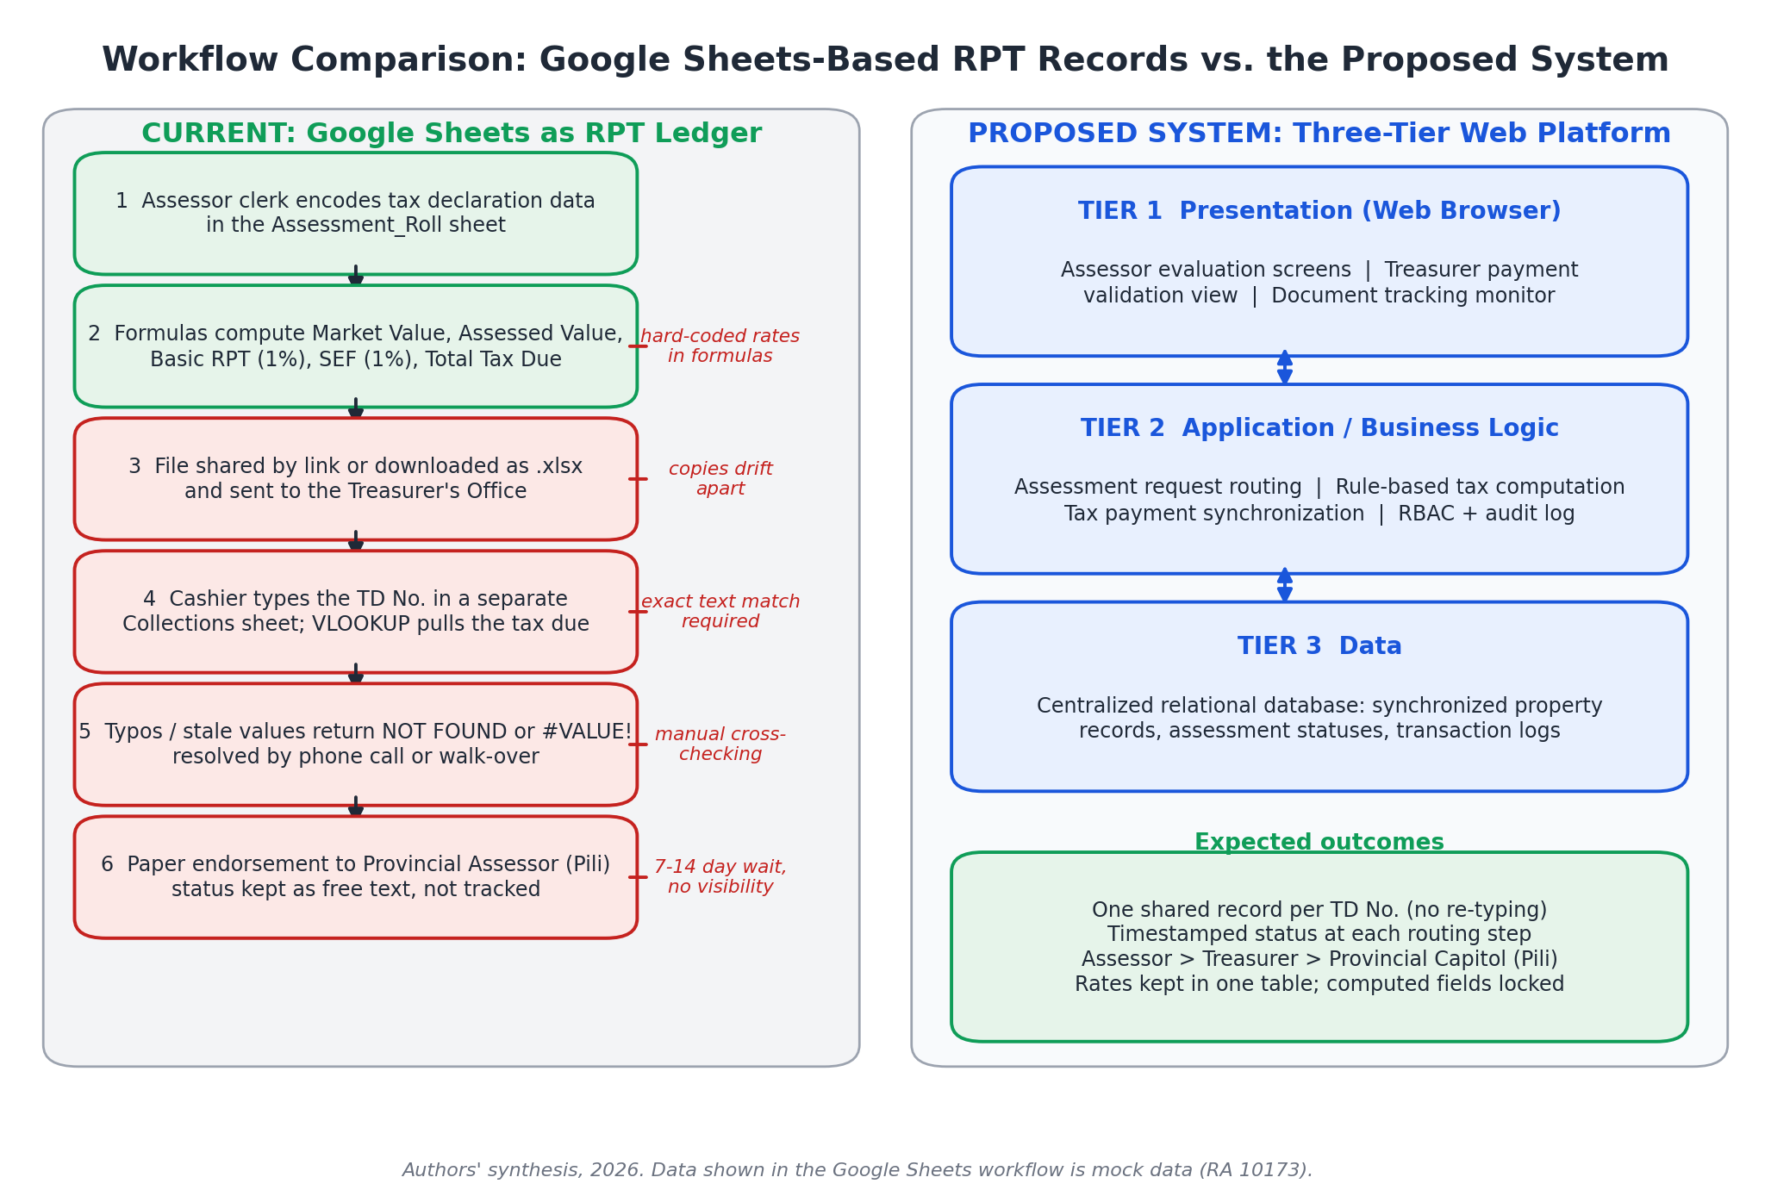
Figure 9. Workflow Comparison: Google Sheets-Based RPT Record Keeping vs. the Proposed System’s Three-Tier Synchronized Web Platform (Authors’ Synthesis, 2026).

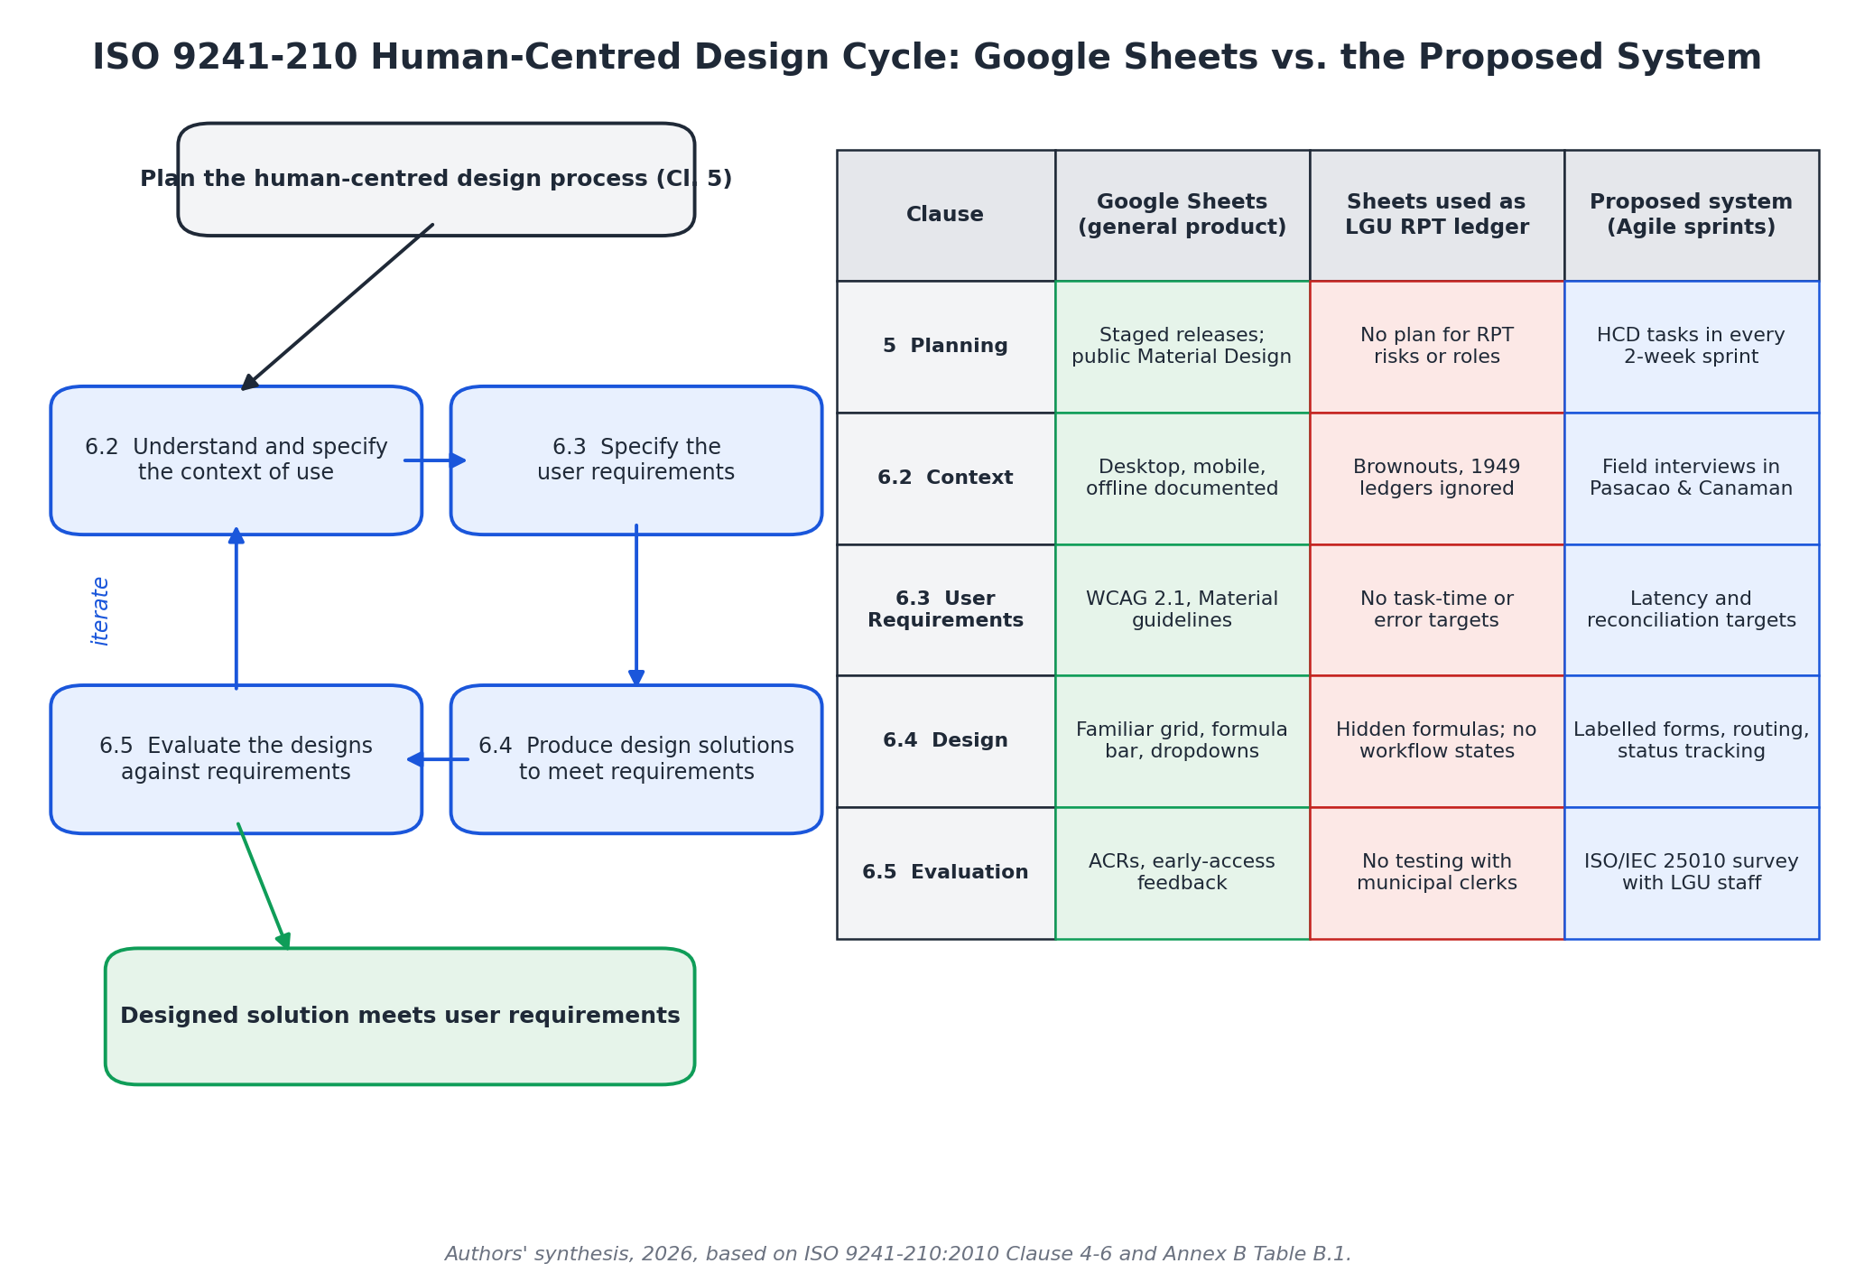
Figure 10. ISO 9241-210 Human-Centered Design Life Cycle: Google Sheets Conformance vs. LGU Deployment Gaps vs. the Proposed System’s Agile Methodology (Authors’ Synthesis, 2026).

Appendix 2: Formal References
Norberto Arrocena Chinilla and Glenne Berja Lagura. 2025. Enhanced tax revenue assessment and collection system through the lens of the municipal treasurers and assessors. International Journal for Multidisciplinary Research (IJFMR) 7, 4 (2025), 1–42. DOI: https://doi.org/10.36948/ijfmr.2025.v07i04.51726
Department of Information and Communications Technology. 2023. Electronic Real Property Tax System (eRPT) Implementation Guidelines and Local Government Technical Standards. DICT, Quezon City, Philippines.
Google. 2026. Accessibility Conformance Reports. Google Accessibility. Retrieved October 13, 2026 from https://www.google.com/accessibility/conformance-reports/
Google. 2026. Create an in-cell dropdown list. Google Docs Editors Help. Retrieved October 13, 2026 from https://support.google.com/docs/answer/186103
Google. 2026. Files you can store in Google Drive. Google Drive Help. Retrieved October 13, 2026 from https://support.google.com/drive/answer/37603
Google. 2026. Find what’s changed in a file. Google Docs Editors Help. Retrieved October 13, 2026 from https://support.google.com/docs/answer/190843
Google. 2026. Protect, hide & edit sheets. Google Docs Editors Help. Retrieved October 13, 2026 from https://support.google.com/docs/answer/1218656
Google. 2026. Share files from Google Drive. Google Drive Help. Retrieved October 13, 2026 from https://support.google.com/drive/answer/2494822
Google. 2026. Work on Google Docs, Sheets, & Slides offline. Google Docs Editors Help. Retrieved October 13, 2026 from https://support.google.com/docs/answer/6388102
Google Workspace Updates. 2022. New functions in Google Sheets: XLOOKUP, XMATCH, LAMBDA, and named functions (August 2022 posts). Retrieved October 13, 2026 from https://workspaceupdates.googleblog.com/2022/08/
Google Workspace Updates. 2024. Convert data ranges to tables in Google Sheets (May 2024 posts). Retrieved October 13, 2026 from https://workspaceupdates.googleblog.com/2024/05/
International Organization for Standardization. 2006. ISO 9241-110:2006: Ergonomics of human-system interaction — Part 110: Dialogue principles. ISO, Geneva, Switzerland.
International Organization for Standardization. 2010. ISO 9241-210:2010: Ergonomics of human-system interaction — Part 210: Human-centred design for interactive systems. ISO, Geneva, Switzerland.
Ma. Angelica Mendoza. 2025. Comparative study on the manual and computer-assisted assessment of real property taxes in Victoria, Laguna. International Journal of Research Publications (IJRP) 173, 1 (2025), 1104–1148. DOI: https://doi.org/10.47119/10.47119/IJRP1001731520257969
Republic of the Philippines. 1991. Republic Act No. 7160: An Act Providing for a Local Government Code of 1991. Official Gazette of the Republic of the Philippines, Manila.
Republic of the Philippines. 2012. Republic Act No. 10173: Data Privacy Act of 2012. Official Gazette of the Republic of the Philippines, Manila.
Republic of the Philippines. 2024. Republic Act No. 12001: Real Property Valuation and Assessment Reform Act (RPVARA). Official Gazette of the Republic of the Philippines, Manila.
Maria Santos and Juan Reyes. 2024. Assessing administrative efficiency and revenue collection bottlenecks in municipal real property taxation. Philippine Journal of Public Administration 68, 2 (2024), 112–135.

